Who doesn’t love that TROPICAL SOUND in the summer time? And it’s time to start the 2023 summer off with one of the top Trop-Rock Bands “PEACH’S BEACH PARTY”. Let us transport you to a tropical island in the Caribbean with the tiki hut looking stage and our beachcomber style dress. All that’s left is the songs of Jimmy Buffett and Friends like The Beach Boys, Zac Brown Band, Bob Marley, Kenny Chesney, Alan Jackson and more. For all those who feel, “Its Five O’clock Somewhere”, “Growing Older But Not Up”, and “We Are The People Our Parents Warned Us About” put on you Hawaiian shirt, grass skirt, coconut bra (men or women) or come and be a pirate for a day.

CLICK ON HERE FOR SHORT PROMO
MORE LINKS BELOW

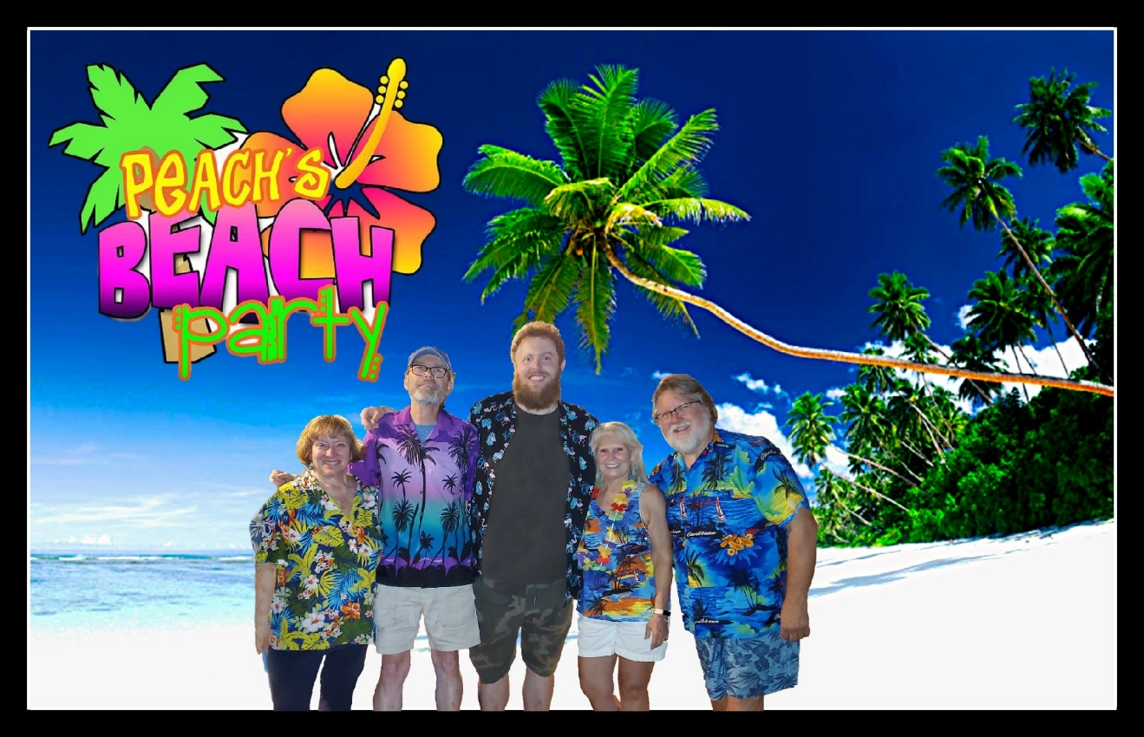

Some of our clients include: Click 2022 CALENDAR to see where we have been.

Performing weekly at Island Party Hut, on the Chicago River Walk. 2021
Fairs:
Illinois State Fair, 2017, 2019,2020 & 2021; DuPage County Fair, 2018; Lake County Fair, 2019; Kendall County Fair, 2019.
Festivals:
Hampshire Illinois; Round Lake Beach; Glendale Heights; Antioch; Palos Hills; Marshall Illinois, Elwood fest IL
Summer Concerts:
Glenview; Frankfort; Algonquin; Elmwood Park; Wauconda; Wildwood; Hawthorn Woods; Cary; Bolingbrook; Westmont; Highland Park; LaGrange Park; Oak Lawn; Brookfield; Bartlett; Arlington Heights; Morton Grove; Sun City Huntley; Bloomingdale; Roselle.
Corporate:
Windy City Bulls; Calamos Investments; Gateway Grizzlies Baseball Team; Boomer Baseball Team; Crystal Tree Country Club; Boulder Ridge Country Club;
Four Winds Casino.

We also entertain at private home parties.

We can scale the band from a 2 piece to a 5 piece to fit your venue needs.

Pricing ranges from $400-$1,200 without sound. There is an addition fee for sound and crew. Call for exact pricing.

So don’t delay! Fins Up __/)__\O/__(\__

PROMO VIDEO

LIVE VIDEOS
SAIL ON SAILOR
KOKOMO
MEXICO
TOES
5 O’CLOCK SOMEWHERE
HOT HOT HOT

LIVE AUDIO
ONE PARTICULAR HARBOR
BROWN EYED GIRLhttps://soundcloud.com/peachs-beach-party
JAMAICAN BIRTHDAY SONG
VOLCANO

PEACHSBEACHPARTY.COM

FACE BOOK

YOUTUBE

Fins Up (^^^^)
Ron Piech
PeachsBeachParty@comcast.net
630-217-0896

