Things are starting to look up in 2021. Our concerts in the park and fest clients are booking 2021 with great optimism that they will be holding their events this summer. Peach’s Beach Party understands that things can change at any time and will not hold any client to their contract that has to cancel because of covid restrictions.

When life gives you lemons you make lemonade! So, with our limited schedule in 2020 we have been able to work on new material and some surprises. Spoiler alert a SURF CONTEST.

Who doesn’t love that TROPICAL SOUND in the summertime? It’s time to start booking one of the top “Trop-Rock” bands, PEACH’S BEACH PARTY for your 2021 summer events!

The following list sent as an attachment, are Facebook groups PEACH’S BEACH PARTY share posts with. When we post your event on Facebook, it is shared with all the band member’s personal Facebook pages. This includes 14 groups with a total of 38,000 plus memberships. Imagine if we reach only 3% of viewers in the venue area? That would be an additional 1,000 possible attendees! We also “boost” our events in a 25 mile radius of your event which reaches another 800 to 1,500 people in the target area.

I hope this shows PEACH’S BEACH PARTY’S commitment in supporting your groups function, not only by performance excellence, but with marketing and advertising strategies.

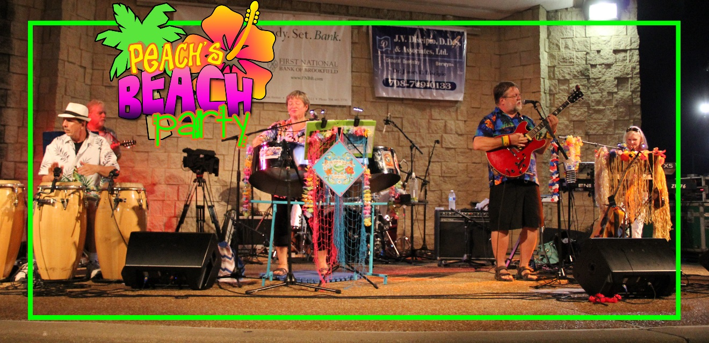

PEACH’S BEACH PARTY is a “Trop-Rock” band playing songs of Jimmy Buffet and friends like The Beach Boys, Zac Brown Band, Bob Marley, Kenny Chesney, Alan Jackson and so much more.

We attract the very large Parrot Head population and, all of the others who feel….”It’s Five O’clock Somewhere,” “Growing Older But Not Up” and “We Are The People Our Parents Warned Us About!”

Some of our clients include:
Fairs:
Illinois State Fair, 2017, 2019,2020 & 2021; DuPage County Fair, 2018; Lake County Fair, 2019; Kendall County Fair, 2019.
Festivals:
Hampshire Illinois; Round Lake Beach; Glendale Heights; Antioch; Palos Hills; Marshall Illinois.
Summer Concerts:
Glenview; Frankfort; Algonquin; Elmwood Park; Wauconda; Wildwood; Hawthorn Woods; Cary; Bolingbrook; Westmont; Highland Park; Lagrange Park; Oak Lawn; Brookfield; Bartlett; Arlington Heights; Morton Grove; Sun City Huntley.
Corporate:
Windy City Bulls; Calamos Investments; Gateway Grizzlies Baseball Team; Boomer Baseball Team; Crystal Tree Country Club; Boulder Ridge Country Club.

We also entertain at private home parties.

We can scale the band from a 3 piece to a 6 piece to fit your venue needs.

Pricing ranges from $400 -$1,200 without sound. There is an addition fee for sound and crew. Call for exact pricing.

So don’t delay! Fins Up __/)__\O/__(\__

PROMO VIDEO

LIVE VIDEOS
SAIL ON SAILOR
KOKOMO
MEXICO
TOES
5 O’CLOCK SOMEWHERE
HOT HOT HOT

LIVE AUDIO
ONE PARTICULAR HARBOR
BROWN EYED GIRLhttps://soundcloud.com/peachs-beach-party
JAMAICAN BIRTHDAY SONG
VOLCANO

PEACHSBEACHPARTY.COM

FACE BOOK

YOUTUBE

Fins Up (^^^^)
Ron Piech
PeachsBeachParty@comcast.net
630-217-0896

